Week 4 Day 2 July 21, 2026

DOM, DOM events and event handler

Exercise
https://codepen.io/chaumdh/pen/vEgazKP
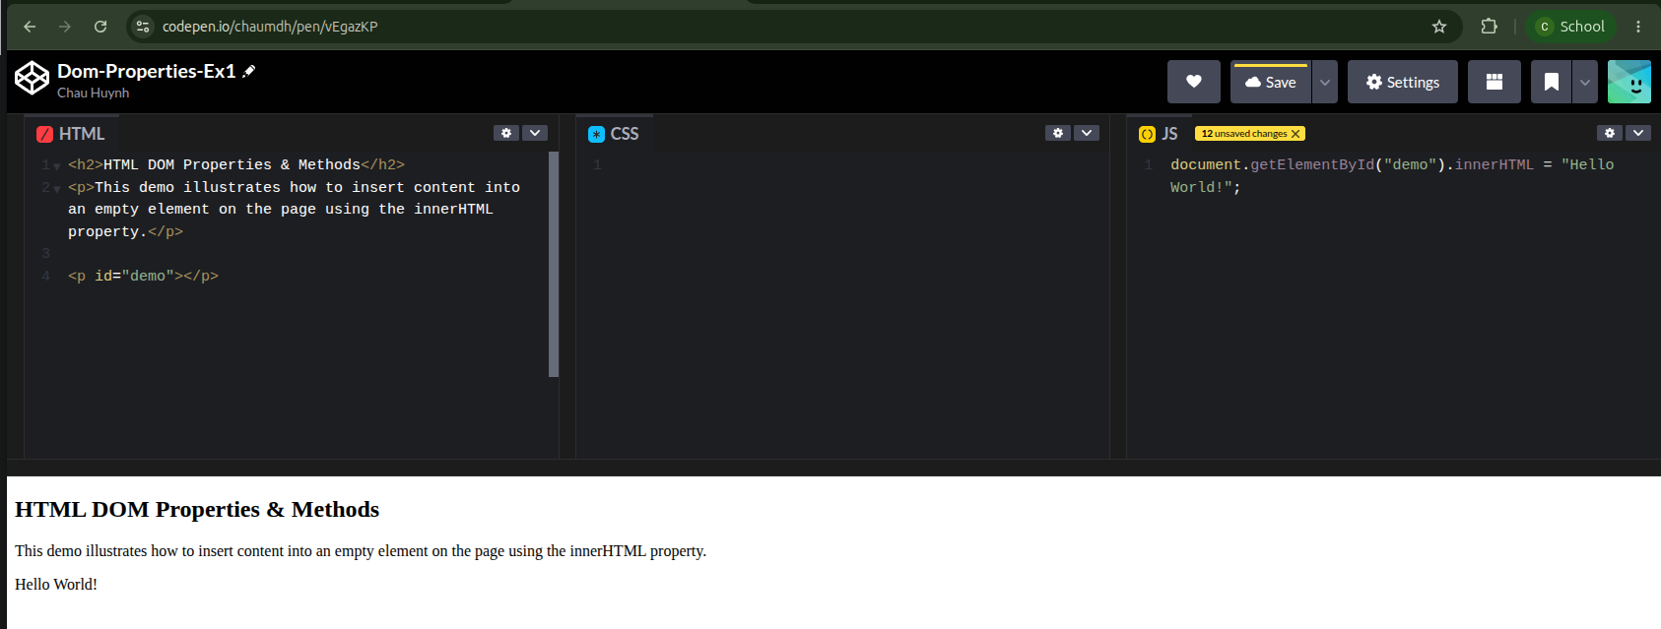

https://codepen.io/chaumdh/pen/XJpBPNz
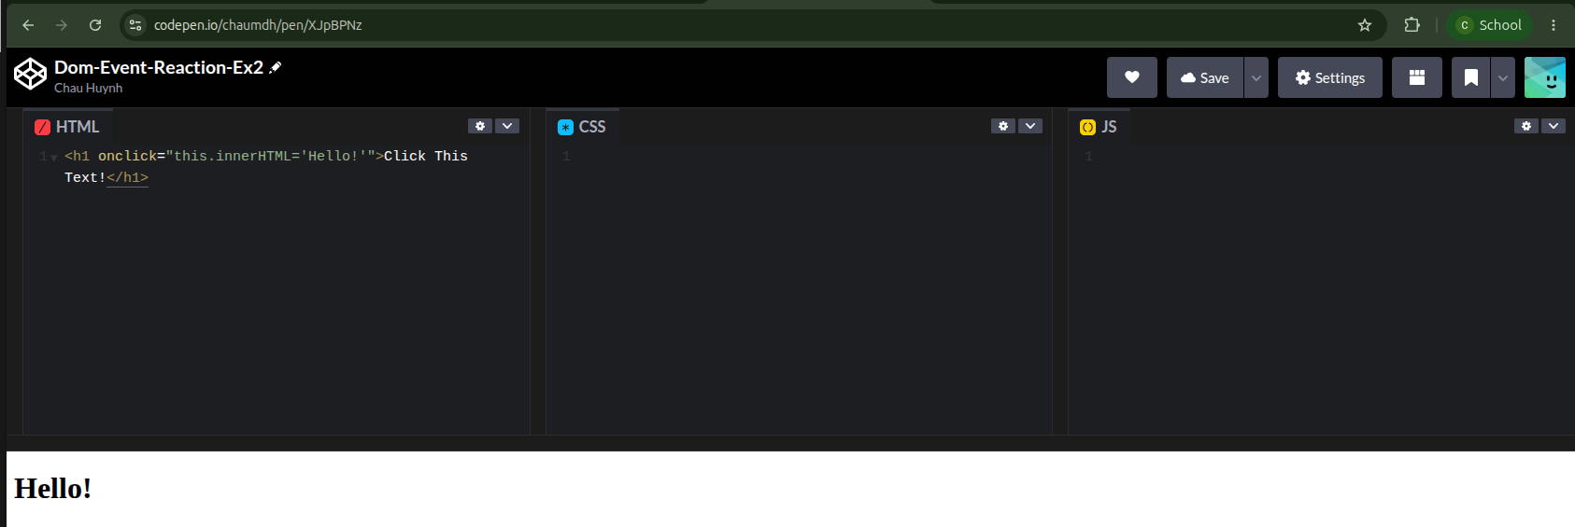

https://codepen.io/chaumdh/pen/WbRKgRw
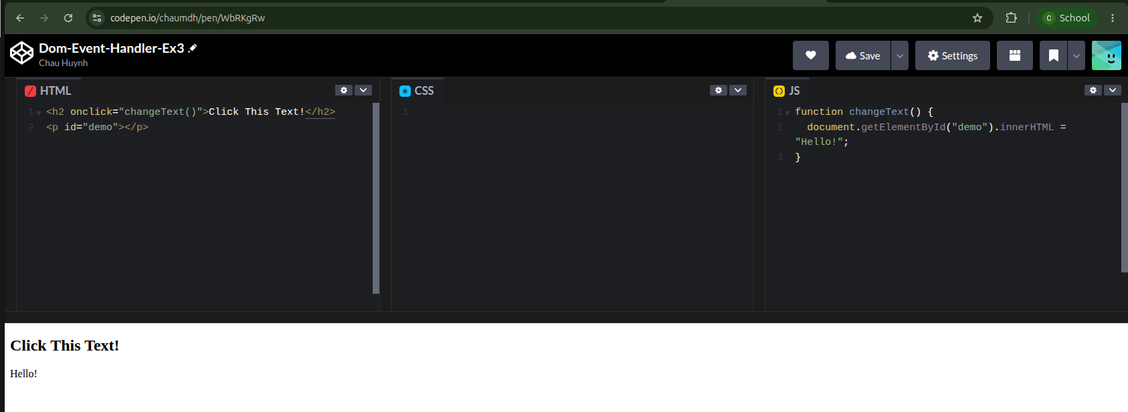

https://codepen.io/chaumdh/pen/myRjGRZ
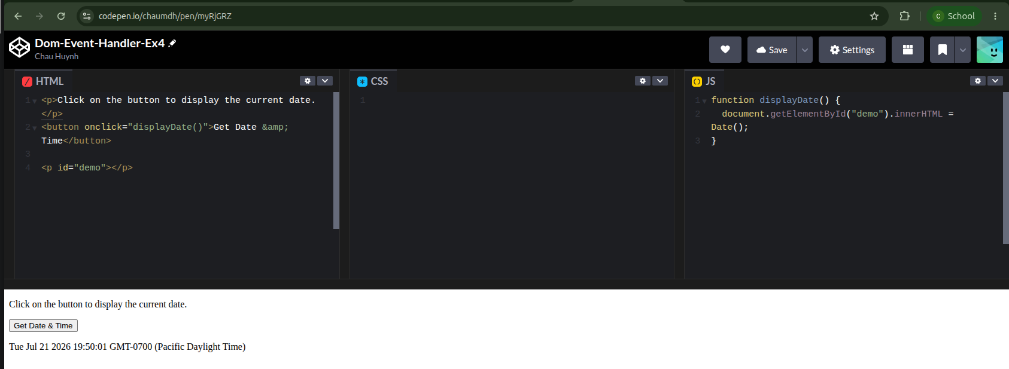

https://codepen.io/chaumdh/pen/NPdBLjN
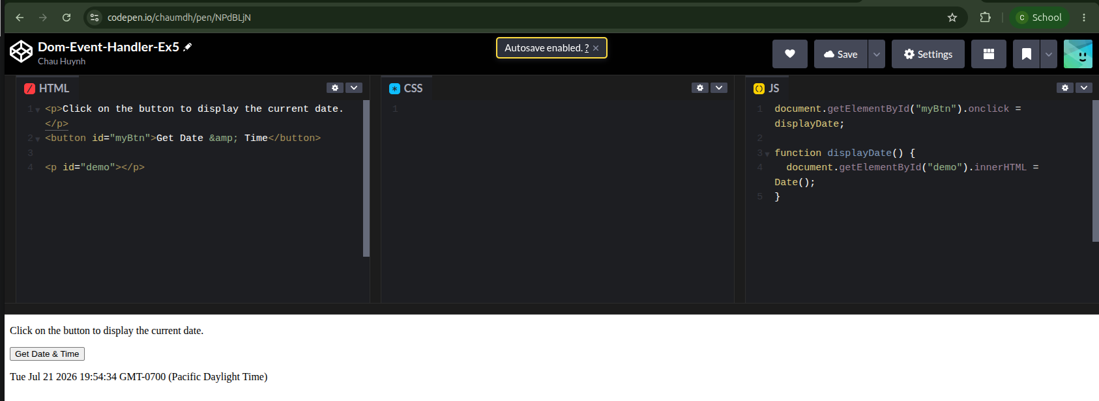

https://codepen.io/chaumdh/pen/BypPOZN
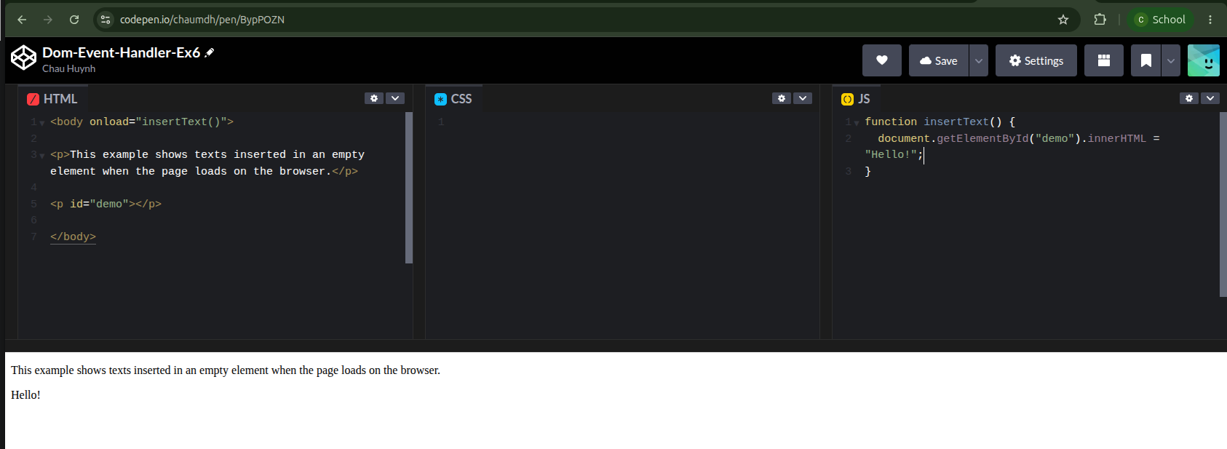

https://codepen.io/chaumdh/pen/qERyMjJ
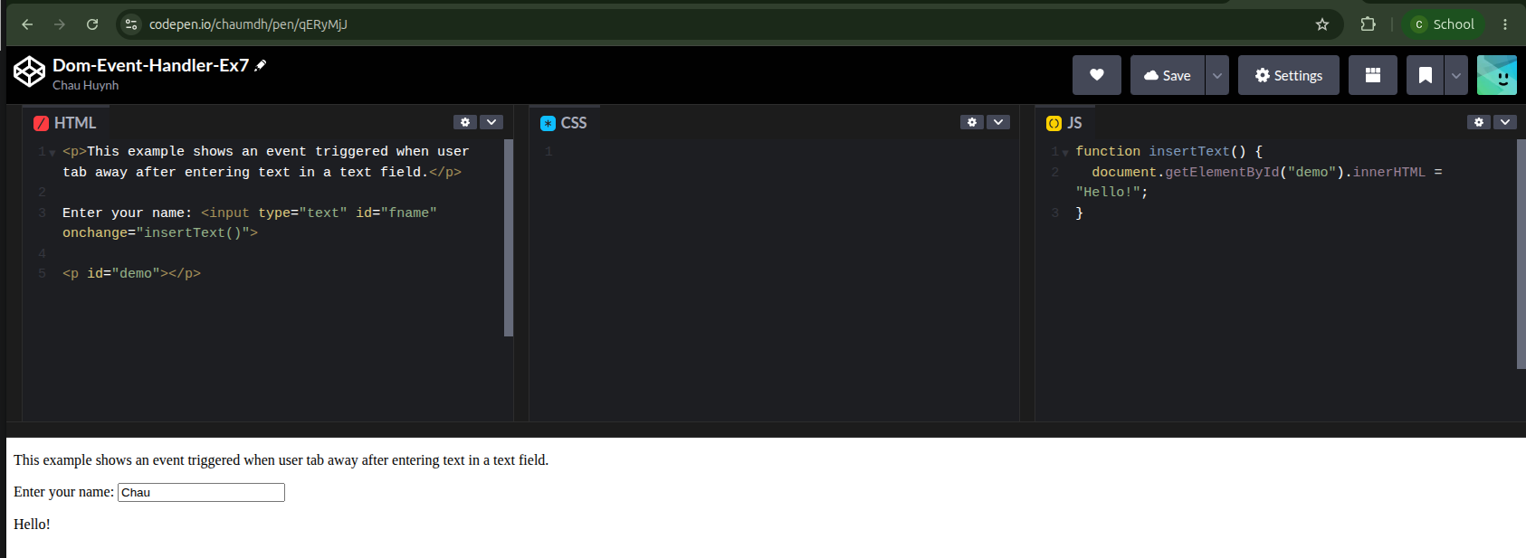

https://codepen.io/chaumdh/pen/myRjGMN
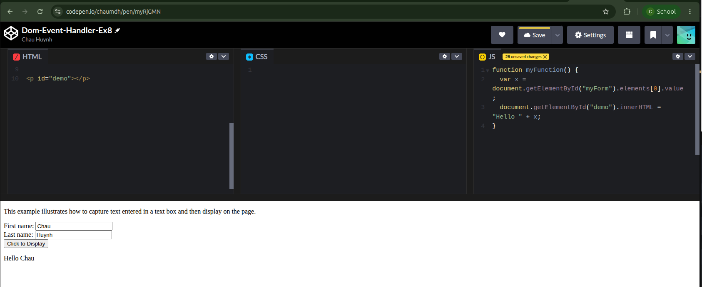

https://codepen.io/chaumdh/pen/VYPBGMR
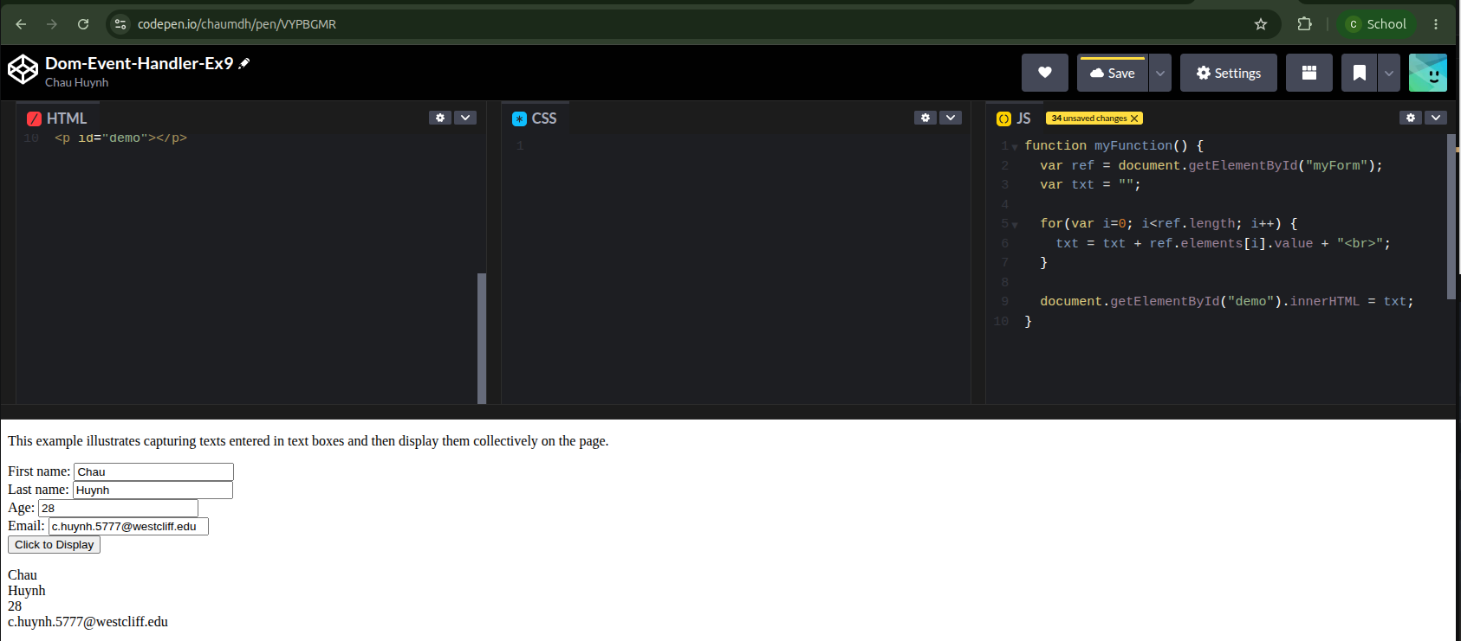

https://codepen.io/chaumdh/pen/ZYLjMva
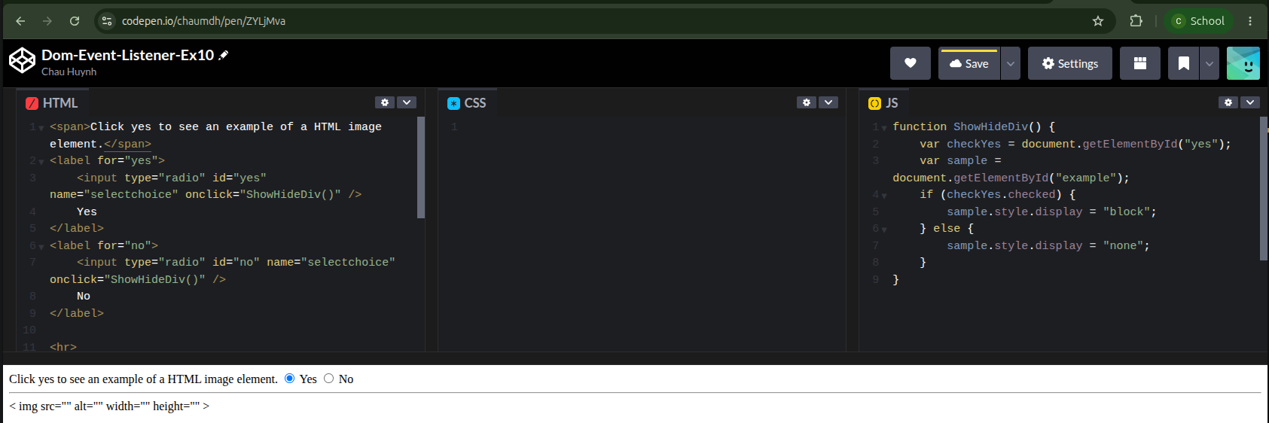

https://codepen.io/chaumdh/pen/gbgjdvb
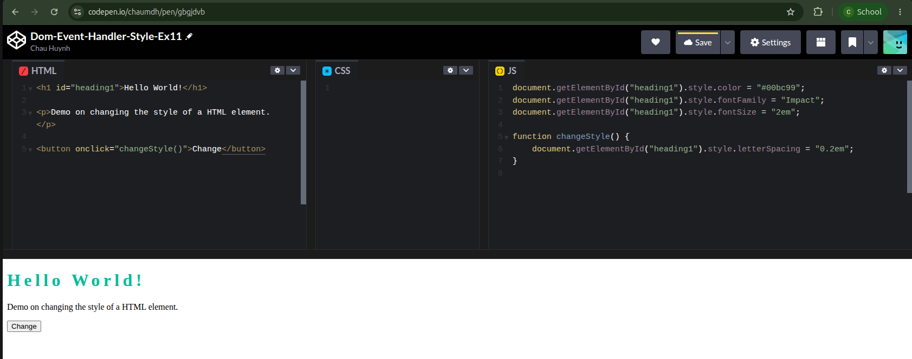
https://codepen.io/chaumdh/pen/wBgxEmG
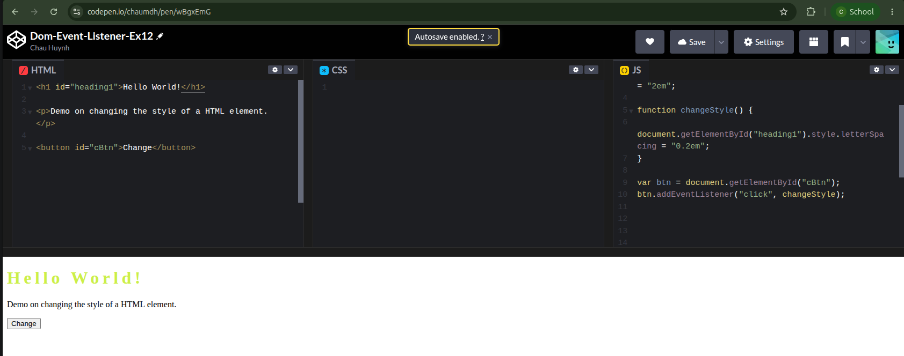

Group challenge

Week-4-Day-2-Participation
Participant Names:
- Melany Ramirez
- Chau Huynh
// variable declarations
function increment() {
var txt = document.getElementById("clickme").innerHTML;
var words = txt.split(" ");
var num = words[words.length-1];
var count = Number(num) + 1;
document.getElementById("clickme").innerHTML = "Click me: " + count;
}

// button events
document.getElementById("clickme").onclick = increment;

function resetCounter() {
document.getElementById("clickme").innerHTML = "Click me: 0";
}

document.getElementById("resetme").onclick = resetCounter;// variable declarations
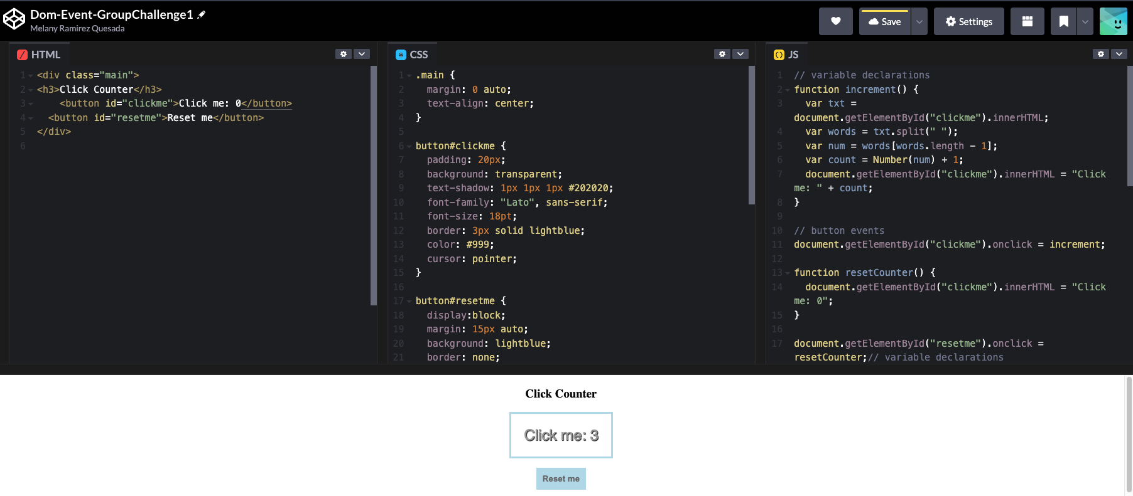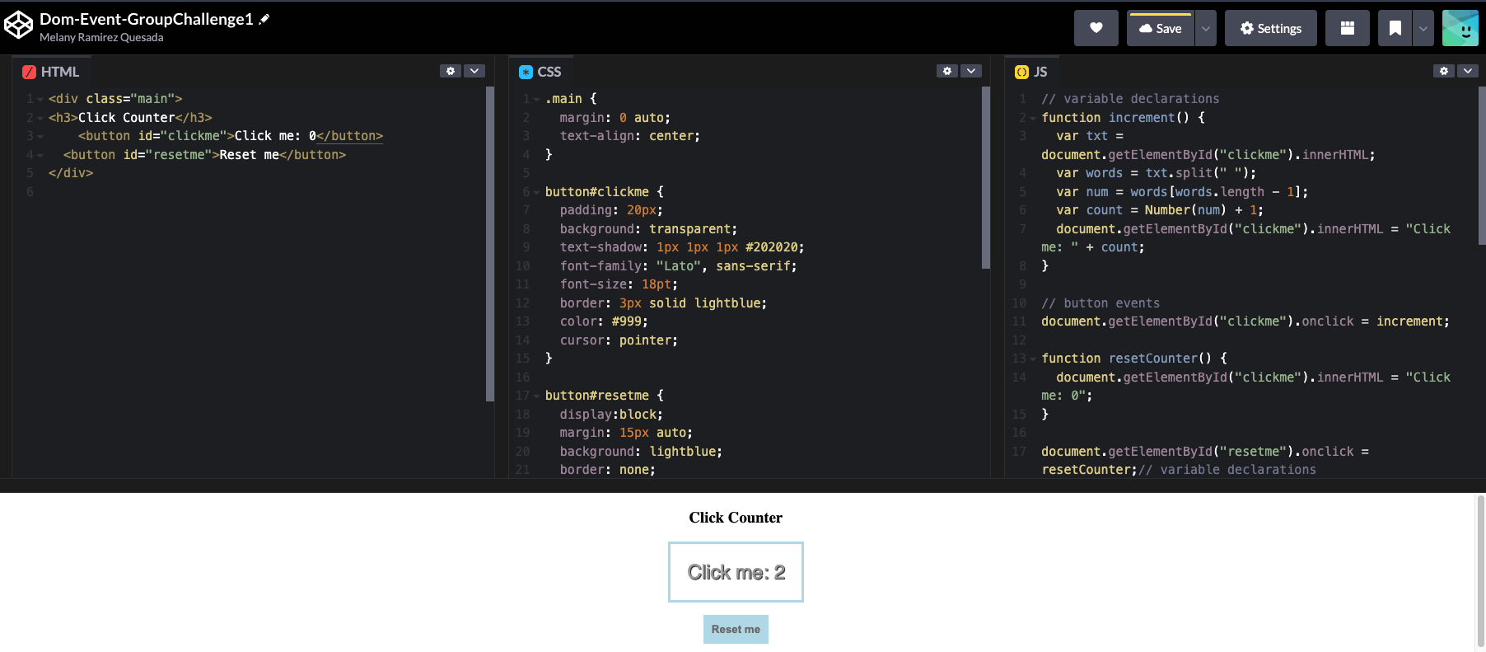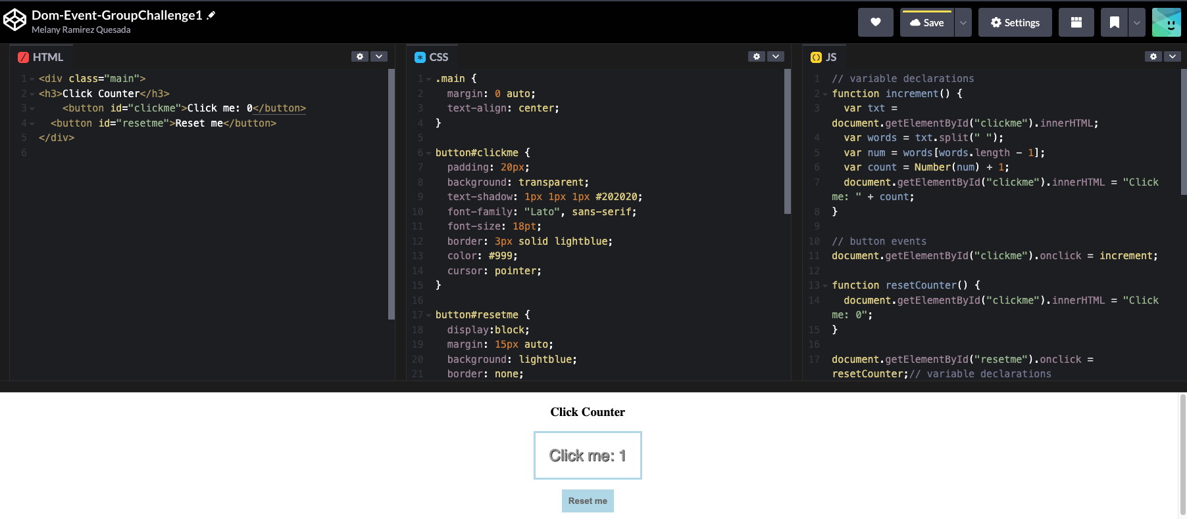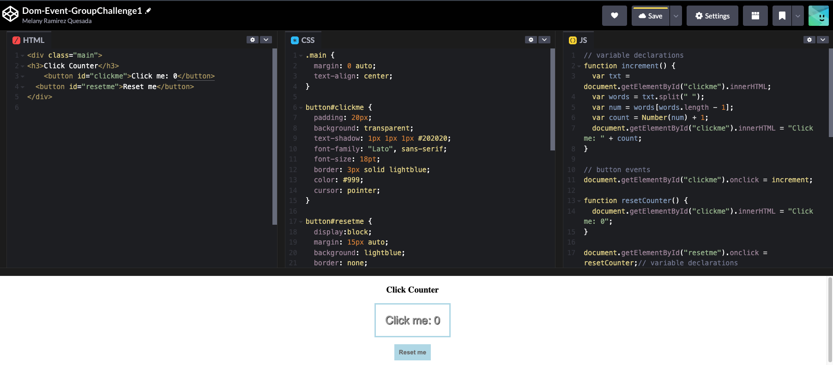

Homework
